
Authorization for Automatic Deposits to Bank Account
Mid Michigan Child Care Food Program
P.O. Box 610 ~ Freeland, MI 48623 ~ 989-695-2683
1-800-PIC-FOOD (742-3663) ~ Fax: 989-695-5488

YOU MUST ATTACH A VOIDED CHECK TO THIS FORM 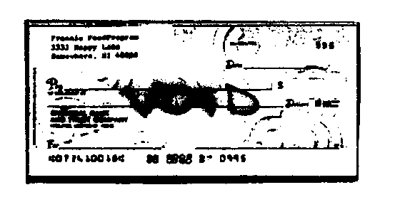

The undersigned hereby authorizes Mid Michigan Child Care Centers, Inc. to make deposits from time to time in the account identified below at (the Bank) and authorizes the Bank to accept such deposits. It is agreed that these deposits may be made electronically and under the Rules of the Michigan Automated Clearning House Association. This authorization will remain in effect until written notice of termination is given to Mid Michigan Child Care Centers, Inc.
Bank Branch ___________________________________ Bank Phone Number __________________
Account # _____________________________________ Rounting Number _____________________
Type of Account ◻ Checking ◻ Savings
Account name if joint or in the name of other than the undersigned ____________________________________________________________________________________
Name of authorizing party (print) ________________________________________________________
Signature of authorizing party ___________________________________________________________

Street Address City State Zip
Date _____________________________

ATTACH A VOIDED CHECK TO THIS FORM

